Subject "Pharmaceutical chemistry 2"
Lecture 7. Antihypertensive and hypertensive drugs.
Blood pressure is the pressure that blood exerts on the walls of blood vessels, in other words, the excess pressure of the fluid in the circulatory system over atmospheric pressure. One of the vital signs and biomarkers.
Blood pressure is most commonly referred to as blood pressure. In addition to it, the following types of blood pressure are distinguished: intracardiac, capillary, venous. With each heartbeat, blood pressure fluctuates between the lowest, diastolic (from other Greek διαστολή "rarefaction") and the highest, systolic (from other Greek συστολή "compression").
Persistent increase in blood pressure above 140/90 mm Hg. Art. (arterial hypertension) or a persistent decrease in blood pressure below 90/60 (arterial hypotension) can be symptoms of various diseases (in the simplest case, hypertension and hypotension, respectively).
Arterial hypertension, arterial hypertension; hypertension (other Greek ὑπέρ “above, above” + τόνος “tension; tone”) is a syndrome of increased systolic blood pressure (SBP) from 140 mm Hg. Art. and above, and simultaneously or independently - diastolic blood pressure (DBP) ≥ 90 mm Hg. Art.
Essential hypertension (hypertension) accounts for 90-95% of cases of hypertension. In other cases, secondary, symptomatic arterial hypertension is diagnosed: renal (nephrogenic) - 3-4%, endocrine - 0.1-0.3%, hemodynamic, neurological, stress, caused by the intake of certain substances (iatrogenic) and hypertension in pregnant women, in which an increase in blood pressure is one of the symptoms of the underlying disease. Among iatrogenic hypertension, those caused by the intake of biologically active additives and drugs stand out. Women taking hormonal contraceptives are more likely to develop hypertension (this is especially noticeable in obese women, women who smoke, and older women). With the development of hypertension against the background of taking these drugs and dietary supplements, they should be canceled. The decision to cancel other drugs is made by the doctor. Hypertension not caused by oral contraceptives is not a contraindication to hormone replacement therapy in postmenopausal women. However, when starting hormone replacement therapy, blood pressure (blood pressure) should be monitored more often, as it may increase.
Antihypertensive drugs are a group of medicines that are used to treat high blood pressure to lower blood pressure. These drugs are used in different situations, both for the treatment of essential hypertension, and for the manifestation of high blood pressure as a symptom in other diseases.
Most of the practical recommendations for the treatment of arterial hypertension are focused on patients older than 45-50 years, while the treatment of patients younger than 40 years, especially with isolated systolic hypertension, has been the subject of discussion for many years, due to the fact that there is no consensus among experts who are divided on supporters of the points of view "false (innocent) hypertension" and "true hypertension", as well as the fact that there is no convincing evidence of the effectiveness of therapeutic strategies for managing patients at this age.
Lifestyle modification is given priority. It is necessary to start treatment of arterial hypertension with non-drug therapy and treatment of diseases, the symptoms of which are secondary hypertension, as well as symptomatic components of hypertension. Non-drug treatment of arterial hypertension includes a diet with a restriction of salt, fats, easily digestible carbohydrates, a favorable regime of work and rest, stress management, avoiding alcohol abuse, smoking, use of other psychoactive substances, daily moderate physical activity, normalization of body weight. Only when this approach is ineffective, non-drug therapy is supplemented with drug treatment.
The goal of medical treatment is to reduce blood pressure (not just lowering the pressure, but eliminating the cause of this high pressure) - below 140/90 mm Hg. st, except for patients with high / very high risk (diabetes mellitus, coronary artery disease, etc.), for whom the target blood pressure is less than 130/80. At the beginning of treatment (depending on risk stratification), mono- or combination therapy is indicated. When monotherapy is ineffective, the use of low-dose combinations of antihypertensive agents is preferable to monotherapy with the same drug, but at the maximum dose. In accordance with the recommendations, first of all, drugs that improve the prognosis (reduce mortality and the risk of non-fatal heart attacks and strokes) are prescribed.
The main determinant of reducing the risk of developing cardiovascular events is the magnitude of the decrease in blood pressure and/or peripheral vascular stiffness and myocardial hypertrophy, and not a specific drug. In the ACCOMPLISH trial, treatment with amlodipine and benazepril was associated with a 20% reduction in CV events compared with the combination of hydrochlorothiazide and benazepril, despite more adequate intraday control with the second combination.
Some patients have comorbidities such that their presence dictates the use of specific antihypertensive drugs, since these drugs have positive effects independent of lowering blood pressure. For example, after the ALLHAT study, alpha-blockers are still used for the treatment of hypertension in patients with BPH, although they have not been recommended for the continuous treatment of hypertension itself (this does not apply to beta-blockers with alpha-blocker properties, which are still used to treat hypertension itself).
For patients who do not have special indications, the main classes of antihypertensive agents will be thiazide or thiazide-like diuretics, the diuretic torasemide, ACE inhibitors or angiotensin receptor blockers (ARBs), long-acting calcium channel blockers of the nifedipine group. Since there is evidence that the combination of ACE inhibitors and calcium channel blockers is highly effective, it is recommended to use drugs from these groups for initial therapy, since if combination therapy is necessary, it will be possible to provide the patient with a highly effective combination by simply prescribing another drug.
Following this approach, the best choice for young patients (when women use contraceptives) will be an ACE inhibitor, and for older patients and Africans (because they have a significantly higher incidence of side effects of ACE inhibitors), the best choice would be a calcium channel blocker of the dihydropyridine group , although in the elderly it may be appropriate to use an ACE inhibitor for the treatment and prevention of heart failure (with the addition of beta-blockers in the presence of heart failure or asymptomatic left ventricular dysfunction), and the frequency of hyperkalemia can be drastically reduced by prescribing a combined drug of an ACE inhibitor and diuretics or additional prescription of diuretics. Individuals who have undergone high-tech interventions, or who have a dry cough and other side effects when taking ACE inhibitors, are prescribed ARAs - instead of ACE inhibitors or in case of diabetic or IgA nephropathy, together with a minimum dose of ACE inhibitors in the absence of side effects.
If the drug of choice in this patient is a thiazide diuretic, then preference should be given to chlorthalidone. If the patient's blood pressure does not decrease, it would be reasonable to prescribe a drug from another group to the patient, while initially not resorting to combination therapy.
In patients whose blood pressure exceeds the target by 20/10 mm Hg. Art., it is recommended to start treatment with combination therapy, which consists of a calcium channel blocker of the dihydropyridine group and an ACE inhibitor, with the addition of a diuretic.
At the same time, the inclusion of calcium channel blockers in therapy increases the risk of breast cancer by 2.5 times in women aged 55–74 compared with those taking other antihypertensive drugs and those not taking medications. Theoretically, this may also mean a negative effect of calcium channel blockers on the prognosis of the development of other oncological diseases.
Classification of antihypertensive drugs
1. Diuretics
b) Thiazide and thiazide-like
c) Potassium-sparing
d) Carbonic anhydrase inhibitors
2. Adrenergic receptor antagonists
a) alpha blockers
b) Beta-blockers
c) Alpha and beta blockers
3. Adrenergic receptor agonists
a) Alpha2 agonists
4. Calcium channel blockers
5. ACE inhibitors
6. Angiotensin-2 receptor antagonists
7. Aldosterone antagonists
8. Vasodilators
9. Centrally acting adrenergics or alpha receptor stimulants in the brain
10. Direct renin inhibitor
Diuretics.
For the treatment of arterial hypertension, mainly saluretics are used, that is, drugs that enhance the excretion of sodium and chlorine ions from the body. So, a pronounced and persistent hypotensive effect is given by thiazide diuretics (derivatives of sulfanilamide antibiotics). The synthesis of thiazide-like diuretics (indapamide, chlorthalidone) was undertaken to reduce the undesirable effects of long-term use of large doses of thiazide diuretics (increased cholesterol, uric acid levels). Most diuretics also reduce the concentration of potassium in the blood, so they are used with caution in arrhythmias and diabetes. Since ACE inhibitors increase potassium levels, combined use with an ACE inhibitor is preferred for non-potassium-sparing diuretics. Reducing the doses of saluretics in their combined use also reduces their undesirable effects. Perhaps the combined use (triple therapy) of ACE inhibitors, thiazide or thiazide-like diuretics and low doses of aldosterone antagonists. Diuretics include: hydrochlorothiazide; indapamide; chlorthalidone; triamterene; furosemide; torasemide; amiloride. A separate lecture will be devoted to diuretics.
Aldosterone antagonists.
Spironolactone, also sold under the names Aldactone, Veroshpiron, is a potassium-sparing diuretic, a competitive antagonist of aldosterone and other mineralocorticoids. Spironolactone is used to treat heart failure, edematous conditions such as nephrotic syndrome or ascites in people with liver disease, hypertension, low blood potassium levels, secondary hyperaldosteronism, and Conn's syndrome. The classification of spironolactone as a potassium-sparing diuretic is considered obsolete.
Antagonists and agonists of adrenergic receptors.
This group of drugs was presented in topic 3 of the lecture "Means affecting the adrenergic system". The so-called "old" group of drugs. They have an indirect hypotensive effect due to a decrease in heart rate and cardiac output. Increase survival in heart failure, asymptomatic left ventricular dysfunction and in patients with myocardial infarction. With prolonged use, they contribute to the formation of diabetes mellitus and erectile dysfunction. Derived from international and European recommendations as first-line drugs in the treatment of arterial hypertension, not accompanied by tachycardia, heart failure, asymptomatic left ventricular dysfunction. The main indication for use is combination therapy for heart failure or asymptomatic left ventricular dysfunction (carvedilol and selective long-release beta-blockers, not their usual forms) and various forms of tachyarrhythmias associated with activation of the sympathetic-adrenal system in arterial hypertension. This group of drugs includes: propranolol; sotalol; metoprolol; bisoprolol; labetalol; nebivolol; betaxolol; pindolol; acebutolol; celiprolol; atenolol.

Centrally acting adrenergics or alpha receptor stimulants in the brain.
Sympatholytics. This group of drugs was presented in topic 3 of the lecture "Means affecting the adrenergic system". Preparations of plant origin Rauwolfia alkaloids (raunatin and pure alkaloid reserpine). They block the reserves of norepinephrine at the presynaptic level, increase the tone of parasympathetic innervation, dilate blood vessels, lower the OPS, reduce the IOC, due to inhibition of sympathetic innervation. The effect is slowly established after 1, 2 weeks.
Agonists of imidazoline receptors and agonists of alpha-2-adrenergic receptors in the brain. Not included in international recommendations. Regardless of this, they are used for the treatment of hypertension, often with self-medication.
Clonidine (clophelin)
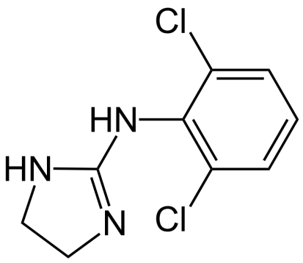
Clonidine is an agonist (activator) of inhibitory alpha2-adrenergic receptors and inhibitory imidazoline I1 receptors on the membranes of neurons in the medulla oblongata (the nucleus of the solitary tract). Like naphazoline and oxymetazoline, clonidine stimulates peripheral α1-adrenergic receptors and has a short-term pressor effect. But, penetrating the blood-brain barrier, it stimulates α2-adrenergic receptors and I1-imadazoline receptors of the nucleus of the solitary tract (nucleus of the solitary tract), which excites the inhibitory interneurons of the vasomotor centers located at the bottom of the rhomboid fossa of the fourth ventricle, and excites the posterior (dorsal) nucleus of the vagus nerve , which enhances the influence of the parasympathetic system on the heart. In connection with a decrease in the secretion of catecholamines, a hypotensive effect occurs.
Methyldopa
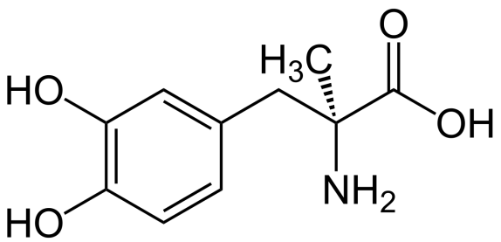
Methyldopa is an effective antihypertensive agent. When introduced into the body, it penetrates the blood-brain barrier and is metabolized in the central nervous system, turning first into methyldopamine, then into α-methylnorepinephrine. The latter, like clonidine, stimulates central α2-adrenergic receptors, inhibits sympathetic impulses, which leads to a decrease in blood pressure. Hypotension is accompanied by a slowdown in heart rate, a decrease in cardiac output, and a decrease in peripheral vascular resistance.
Moxonidine
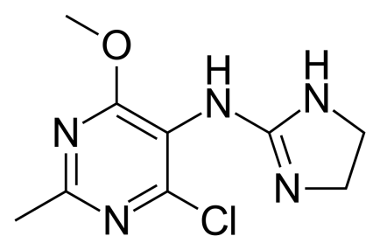
Moxonidine is an antihypertensive drug. It is used to treat arterial hypertension in patients who are overweight (overweight, obesity, diabetes mellitus). By stimulating imidazoline receptors, moxonidine eliminates the influence of the sympathetic nervous system on the development of arterial hypertension and metabolic disorders, including obesity, and insulin metabolism disorders.
Rilmenidine
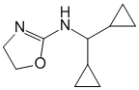
It is a specific agonist of central and peripheral imidazoline (I1) receptors. Excitation of the central imidazoline receptors in the vasomotor center of the medulla oblongata is accompanied by a decrease in sympathetic impulses to the vessels and the heart, which leads to a decrease in blood pressure and peripheral vascular resistance, a decrease in heart rate. In part, the antihypertensive effect is due to the stimulation of alpha2-adrenergic receptors on the membranes of neurons in the nuclei of the solitary tract. Reduces the activity of renin and the content of norepinephrine, angiotensin II and aldosterone.
Guanfacine
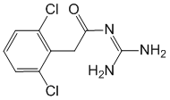
Stimulates central alpha2-adrenergic receptors, as a result of which it reduces impulses along the sympathetic fibers of the autonomic nervous system from the vasomotor center to the heart and blood vessels. Reduces cardiac output, reduces OPSS, lowers SBP and DBP, slightly reduces heart rate. Plasma renin activity decreases.
Vasodilators.
Vasodilation is a medical term used to describe the relaxation of smooth muscle in the walls of blood vessels. This is the result of the process of release of histamine and heparin from mast cells, which leads to the expansion of the lumen of the vessels and adhesion (adherence and penetration from the vessel) of T-lymphocytes into the focus of inflammation. The opposite process of vasodilation is vasoconstriction. Substances that cause vasodilation are often used as drugs for the treatment of hypertension. These drugs include sodium nitroprusside, nevibolol, bradykinin, papaverine, nifedipine.
Sodium nitroprusside.
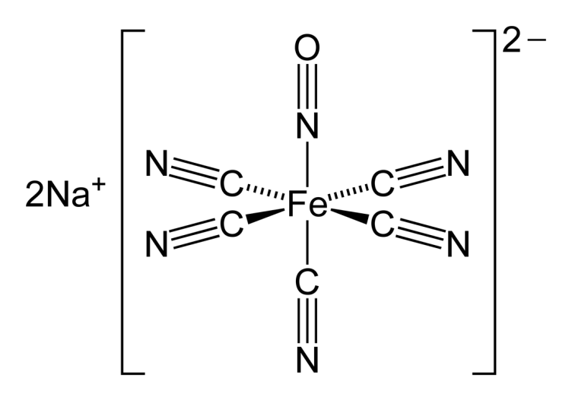
Sodium nitroprusside is a myotropic antihypertensive agent. It affects resistant (arterioles, small arteries) and capacitive (venules, small veins) vessels; it does not increase cardiac output, since venous return to the heart decreases. However, reflexively, the heart rate rises. The principle of the vasodilating action of sodium nitroprusside:
SODIUM NITROPRUSSE - NO; 3-Nitrosothiols-Activation of soluble guanylate cyclase-Increase in the production of intracellular cGMP-Decrease in the content of cytosolic free calcium ions-RELAXATION OF VASCULAR SMOOTH MUSCLE
Nevibolol
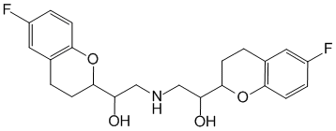
Selectively blocks beta1-adrenergic receptors, modulates the synthesis of endothelial relaxing factor (NO). The decrease in blood pressure is due to a decrease in cardiac output, bcc, OPSS, inhibition of renin formation, partial loss of sensitivity of baroreceptors. The hypotensive effect usually develops after 1-2 weeks and stabilizes within 4 weeks. Lowers heart rate at rest and during exercise, left ventricular diastolic blood pressure, improves diastolic filling of the heart, reduces myocardial oxygen demand (antianginal activity), reduces myocardial mass (by 9.7%) and myocardial mass index (by 5.1%). According to 24-hour monitoring, it has a positive effect on the circadian rhythm of blood pressure in patients with both normal and disturbed rhythms. Does not adversely affect lipid metabolism.
Indications: Arterial hypertension (monotherapy or in combination with other antihypertensive drugs), ischemic heart disease, exertional angina.
Bradykinin
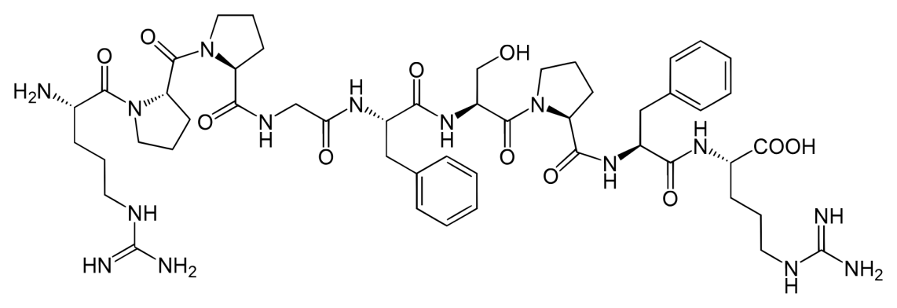
Bradykinin is a peptide that dilates blood vessels and therefore lowers blood pressure. ACE inhibitors[1], which are used to lower blood pressure, increase bradykinin levels. Bradykinin acts on blood vessels to release prostacyclin, nitric oxide. In the human body, bradykinin is degraded by three enzymes: angiotensin-converting enzyme 2, aminopeptidase P, and carboxypeptidase N, which cleave bonds 7-8, 1-2, and 8-9, respectively.

Papaverine
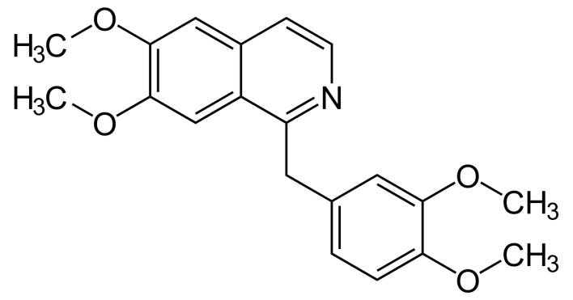
Papaverine (from Latin papaver "poppy") is an opium alkaloid, an isoquinoline derivative, a drug with antispasmodic and hypotensive effects. Isolated from opium and studied in 1848 by Georg Merck (Merck, 1825-1873). Antispasmodic, has a hypotensive effect. Inhibits PDE (phosphodiesterase), causes the accumulation of cycloadenosine monophosphate in the cell and a decrease in the content of Ca2 +; reduces the tone and relaxes the smooth muscles of the internal organs (gastrointestinal tract, respiratory and genitourinary systems) and blood vessels. In large doses, it reduces the excitability of the heart muscle and slows down intracardiac conduction. The effect on the central nervous system is weakly expressed (in large doses it has a sedative effect).
Dibazol
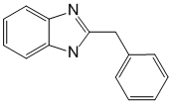
Directly relaxes the smooth muscles of blood vessels and internal organs (refers to myotropic antispasmodics). Facilitates synaptic transmission in the spinal cord. It has a short (2-3 hours) and moderate hypotensive effect, well tolerated. In the treatment of hypertension, it is recommended to combine with other drugs that lower blood pressure. Elderly patients should not be prescribed for a long time as an antihypertensive agent, because. due to a decrease in cardiac output, deterioration in ECG parameters is possible. Indications: Spasms of blood vessels (including coronary spasm, peripheral arteries), exacerbation of hypertension, hypertensive crisis, spasms of smooth muscles of internal organs (gastric ulcer, spasms of the pylorus and intestines, renal and hepatic colic).

Nifedipine
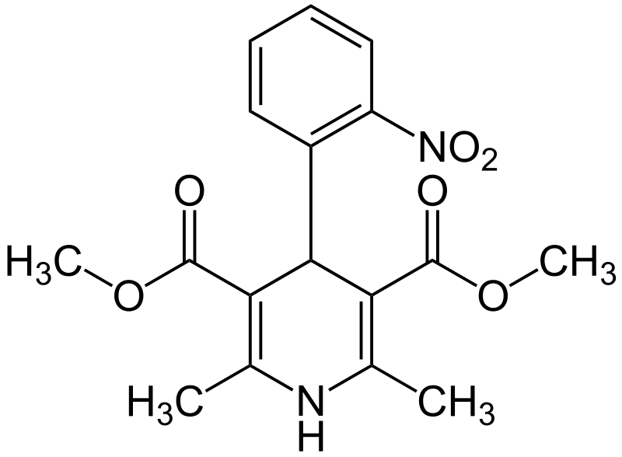
Nifedipine is an antihypertensive drug, a calcium ion antagonist, a 1,4-dihydropyridine derivative: 2,6-dimethyl-4-(2-nitrophenyl)-1,4-dihydropyridine-3,5-dicarboxylic acid dimethyl ester. It inhibits the flow of calcium ions through the membrane of cardiomyocytes and vascular smooth muscles, which leads to a decrease in the accumulation of calcium inside the cells. This causes the expansion of the coronary arteries, peripheral blood vessels, which leads to a decrease in total peripheral vascular resistance (OPVR) and, consequently, a decrease in the load on the heart, an increase in myocardial oxygen supply. By reducing the work of the heart, the drug reduces myocardial oxygen consumption, and also indirectly reduces myocardial oxygen demand by reducing peripheral vascular resistance and afterload. Under the influence of the drug, blood pressure (BP) decreases, chest pain associated with myocardial hypoxia disappears or decreases.
ACE inhibitors.
ACE inhibitors are also drugs used for chronic congestive heart failure. Drugs that act through the renin-angiotensin system in the treatment of hypertension also act as ACE inhibitors, as well as renin inhibitors and angiotensin II antagonists.
ACE inhibitors (angiotensin-converting enzyme inhibitors, ACE inhibitors) are a group of natural and synthetic chemical compounds used to treat and prevent heart failure (usually in doses that do not reduce blood pressure) and kidney failure, to lower blood pressure, in plastic surgery, to protect against ionizing radiation. They were discovered during the study of peptides contained in the venom of the common jararaca (Bothrops jararaca). ACE inhibitors are most widely used in the treatment of hypertension and heart failure.
ACE inhibitors inhibit the action of angiotensin-converting enzyme, which converts biologically inactive angiotensin I into the hormone angiotensin II, which has a vasoconstrictive effect. As a result of exposure to the renin-angiotensin system, as well as enhancing the effects of the kallikrein-kinin system, ACE inhibitors have a hypotensive effect.
ACE inhibitors slow the breakdown of bradykinin, a powerful vasodilator that stimulates blood vessel dilation by releasing nitric oxide (NO) and prostacyclin (prostaglandin I2).
Classification of ACE inhibitors
• Preparations containing sulfhydryl groups: captopril, zofenopril.
• Dicarboxylate-containing drugs: enalapril, ramipril, quinapril, perindopril, lisinopril, benazepril.
• Phosphonate-containing drugs: fosinopril.
• Natural ACE inhibitors.
Caseinins and lactokinins are breakdown products of casein and whey that naturally occur after consumption of dairy products. The role in lowering blood pressure is unclear. Lactotripeptides Val-Pro-Pro and Ile-Pro-Pro are produced by probiotics Lactobacillus helveticus or are breakdown products of casein and have an antihypertensive effect. ACE inhibitors lower blood pressure by lowering total peripheral vascular resistance. Cardiac output and heart rate do not change much. These drugs do not cause the reflex tachycardia associated with direct vasodilators. The absence of reflex tachycardia is achieved by setting the level of baroreceptor activation to a lower level or by activating the parasympathetic nervous system.

Captopril (Capoten, Capril).
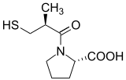
Captopril is a drug, one of the drugs in the group of angiotensin-converting enzyme inhibitors. In the anatomical and therapeutic classification, it is registered under the code C09AA01.
Its active ingredient is based on an enzyme from the venom of the South American jararaka snake Bothrops jararaca[1]. The drug was patented in 1976 and approved for medical use in 1980.
ACE inhibitor. Reduces the formation of angiotensin II from angiotensin I. A decrease in the content of angiotensin II leads to a direct decrease in the release of aldosterone. At the same time, peripheral vascular resistance, blood pressure, post- and preload on the heart decrease. Expands arteries more than veins. It causes a decrease in the degradation of bradykinin (one of the effects of ACE) and an increase in the synthesis of Pg. The hypotensive effect does not depend on the activity of plasma renin, a decrease in blood pressure is noted at normal and even reduced concentrations of the hormone, which is due to the effect on tissue RAAS. Enhances coronary and renal blood flow. With prolonged use, it reduces the severity of myocardial hypertrophy and the walls of the arteries of the resistive type. Improves blood supply to ischemic myocardium. Reduces platelet aggregation. It helps to reduce the content of Na + in patients with chronic heart failure. In doses of 50 mg / day, it exhibits angioprotective properties in relation to the vessels of the microvasculature and can slow down the progression of chronic renal failure in diabetic nephroangiopathy. A decrease in blood pressure, unlike direct vasodilators (hydralazine, minoxidil, etc.), is not accompanied by reflex tachycardia and leads to a decrease in myocardial oxygen demand. In heart failure in an adequate dose does not affect the magnitude of blood pressure. The maximum decrease in blood pressure after oral administration is observed after 60-90 minutes. The duration of the hypotensive effect is dose-dependent and reaches optimal values ​​within a few weeks.
Synthesis of captopril:

Enalapril (Enapril, Enalap)
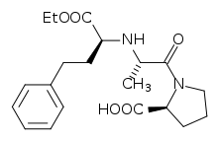
Enalapril (systematic name: (S)-1-[N-[1-(ethoxycarbonyl)-3-phenylpropyl]-L-alanyl]-L-proline) is a drug, one of the drugs in the group of angiotensin-converting enzyme inhibitors. It is mainly used to treat high blood pressure (arterial hypertension), chronic heart failure, to reduce death after heart attacks, and for some kidney problems caused by diabetes. The active metabolite, enalaprilat, is the base drug for the treatment of complicated hypertensive crises in the absence of contraindications.
Synthesis of enalapril:
One of the methods for the synthesis of enalapril is the reductive alkylation of alanylproline with ethyl ester of 2-oxo-4-phenylbutenoic acid under hydrogenation conditions in the presence of palladium black 1.6% or using sodium cyanoborohydride:
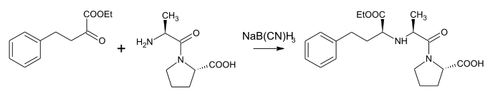
As with other drugs in this group, the clinical effect of enalapril is due to the suppression of the activity of angiotensin-converting enzyme and, as a result, a decrease in the formation of angiotensin II from angiotensin I in tissues and circulating blood. A decrease in the concentration of angiotensin II, in turn, leads to vasodilation, a decrease in the secretion of aldosterone, an increase in the concentration of potassium and renin activity in the blood plasma. The hemodynamic consequences of these changes are a decrease in peripheral vascular resistance (OPVR), systolic and diastolic blood pressure, an increase in cardiac output, and a decrease in post- and preload on the myocardium. The hypotensive effect of the drug is most pronounced with a high concentration of renin in plasma, with a decrease in its concentration, the clinical effect becomes less pronounced. In some patients, therapy for several weeks is necessary to achieve an optimal level of blood pressure.
Lisinopril (Privinil)
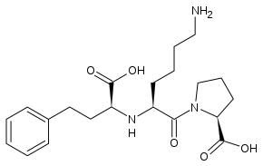

Lisinopril is a long-acting angiotensin-converting enzyme (ACE) inhibitor intended for the treatment of arterial hypertension and the prevention of its complications. A feature of the drug is that it is not metabolized in adipose tissue, which allows it to be effectively used in overweight patients. Reduces the formation of angiotensin II from angiotensin I. A decrease in the content of angiotensin II leads to a direct decrease in the release of aldosterone. Reduces the degradation of bradykinin and increases the synthesis of prostaglandins. Reduces peripheral vascular resistance, blood pressure, preload, pressure in the pulmonary capillaries, causes an increase in the IOC and an increase in myocardial tolerance to stress in patients with CHF. Expands arteries more than veins. Some effects are explained by the effect on the tissue renin-angiotensin system.

Cilazapril.
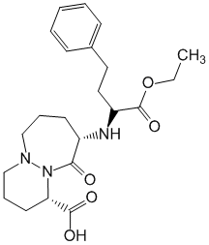
Inhibits ACE and slows down the conversion of angiotensin I to angiotensin II for a long time. Reduces OPSS, aldosterone secretion, lowers the activity of the sympathoadrenal system. Increases the activity of the kallikrein-kinin system, causes the accumulation of bradykinin in tissues and blood (reduces cleavage to inactive peptides). Reduces SBP and DBP both in the standing position and in the supine position, does not cause orthostatic reactions and reflex tachycardia (slight changes in heart rate may be observed). Effective at all stages of hypertension, as well as renal hypertension. Indications: Arterial hypertension (including renovascular), chronic heart failure (as part of combination therapy with digitalis and / or diuretics).
Trandolapril (Gopten)
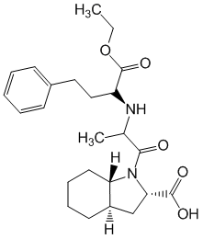
Inhibits ACE and inhibits the formation of angiotensin II, which has a vasoconstrictor effect. Reduces OPSS, systemic blood pressure and afterload on the myocardium, helps to reduce vascular hypertrophy (aorta, mesenteric and femoral arteries). By inhibiting the tissue renin-angiotensin system of the heart, it prevents the development of myocardial hypertrophy and dilatation of the left ventricle or contributes to their regression (cardioprotective action). Increases the level of phosphocreatinine in reperfusion ischemic areas of the myocardium. Suppresses the synthesis of aldosterone in the adrenal glands, stabilizes bradykinin in tissues and blood (its degradation to inactive peptides decreases), increases the activity of the kallikrein-kinin system, increases the release of biologically active substances (PGE2 and PGI2, endothelial relaxing factor, atrial natriuretic factor), which have natriuretic and vasodilating effect and improving renal blood flow. Reduces the formation of arginine-vasopressin and endothelin-1, which have vasoconstrictor properties.
Quinapril
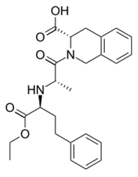
Inhibits ACE due to the interaction of the carboxyl group with the zinc atom in the enzyme molecule and reduces the formation of angiotensin II from angiotensin I. It has tissue specificity: it inhibits ACE activity in plasma, lungs, kidneys, heart and vascular wall, but does not change the activity of the enzyme in the brain and testicles. Increases the concentration of endogenous vasodilating PG, inhibits the metabolism of bradykinin, substance P, enkephalin and other biologically active substances, the secretion of aldosterone, reduces the formation of endothelin-1, which has vasoconstrictor properties. Causes expansion of peripheral vessels (mostly renal and coronary) and improves regional circulation, lowers peripheral vascular resistance, afterload on the myocardium, SBP and diastolic blood pressure. It inhibits the development of nephrosclerosis (especially in patients with diabetes mellitus). Promotes vasodilation, reduces venous return to the heart, ventricular filling pressure and preload on the left ventricle. Restores the baroreflex mechanisms of the heart and large vessels.

Ramipril
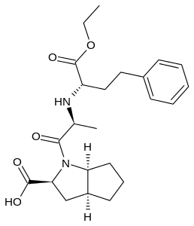
An ACE inhibitor blocks the conversion of angiotensin I to angiotensin II, resulting in (regardless of plasma renin activity) a hypotensive effect (in the patient's position "lying" and "standing") without a compensatory increase in heart rate.
Decreases aldosterone production. Reduces OPSS (afterload), wedge pressure in the pulmonary capillaries (preload), resistance in the pulmonary vessels; increases IOC and exercise tolerance. With prolonged use, it contributes to the regression of myocardial hypertrophy in patients with arterial hypertension and reduces the frequency of arrhythmias during myocardial reperfusion; improves blood supply to ischemic myocardium; prevents changes in the vascular endothelium caused by a high-cholesterol diet.
The cardioprotective effect is due to the influence on the synthesis of Pg, the induction of the formation of nitric oxide (NO) in endotheliocytes. It activates the kallikrein-kinin system, prevents the breakdown of bradykinin (increases its concentration), increases the synthesis of Pg. Enhances coronary and renal blood flow. Reduces platelet aggregation. Increases the sensitivity of tissues to insulin, the concentration of fibrinogen, stimulates the synthesis of the tissue activator profibrinolysin (plasminogen), contributing to thrombolysis.

Benazepril
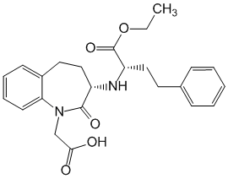
It inhibits angiotensin-converting enzyme and blocks the transition of angiotensin I to angiotensin II, a powerful vasoconstrictor. Secondarily increases the activity of plasma renin and increases the secretion of aldosterone by the adrenal glands. Reduces total peripheral vascular resistance. It affects the kallikrein-kinin system, increases the concentration of bradykinin and the synthesis of PG - local vasodilators.
Fosinopril
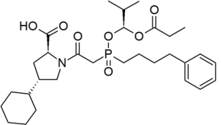
An ACE inhibitor is an antihypertensive drug, the mechanism of action is associated with a decrease in the formation of angiotensin II from angiotensin I, a decrease in the concentration of which leads to a direct decrease in aldosterone secretion. This reduces the total peripheral vascular resistance (OPVR), systolic and diastolic blood pressure, post- and preload on the myocardium. Expands the arteries to a greater extent than the veins, while a reflex increase in heart rate is not observed. Reduces the degradation of bradykinin, increases the synthesis of Pg. With prolonged use, hypertrophy of the left ventricle of the myocardium and the thickness of the interventricular septum decrease. Reduces intraglomerular hypertension, increases glomerular filtration rate, slowing down the development of glomerulosclerosis and the risk of chronic renal failure.

Perindopril
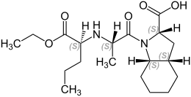
ACE inhibitor (interacts with Zn2+ in the ACE molecule and causes its inactivation). Perindopril acts through its active metabolite, perindoprilat. Eliminates the vasoconstrictor effect of angiotensin II, increases the concentration of bradykinin and vasodilator Pg (ACE converts inactive angiotensin I into angiotensin II, which has a vasoconstrictor effect, and also causes degradation of bradykinin and Pg, which have vasodilatory activity); reduces the production and release of aldosterone, inhibits the release of norepinephrine from the endings of sympathetic nerve fibers and the formation of endothelin in the vascular wall. A decrease in the formation of angiotensin II is accompanied by an increase in plasma renin activity (due to inhibition of negative feedback). Suppression of ACE is accompanied by an increase in the activity of both the circulating and tissue kallikrein-kinin systems, as well as the Pg system.
Moexipril
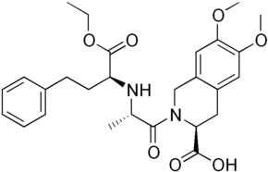
ACE inhibitor. It prevents the formation of angiotensin II, reduces its vasoconstrictive effect, as well as a stimulating effect on the secretion of aldosterone. Reduces OPSS, reduces afterload on the heart, lowers blood pressure.
Direct renin inhibitor
Compounds of this group reduce the formation of angiotensinogen by inhibiting the formation of renin. Of these, the renin inhibitor is pepstatin having a polypeptide structure as a pepsin inhibitor. Not used in therapy. Used in clinical trials.

Angiotensin-2 receptor antagonists
Initially, drugs in this class (saralazine) were imperfect, and ARAs could not compete with ACE inhibitors. As a result of numerous studies, pharmaceutical companies have created sartans that are not inferior to long-acting ACE inhibitors, and, in some cases, having an advantage over some of them. Since the beginning of the 21st century, ARA (ARBs, sartans) has been the most used, “fashionable” group of antihypertensive drugs in the world. ARAs block the AT1 receptors for angiotensin II, a powerful vasoconstrictor factor, no matter how it is formed. Simultaneously, angiotensin-2 stimulation of unblocked type 2 ARA receptors (AT2) causes vasodilation, an increase in nitric oxide production, and stimulation of antiproliferative processes. This allows the use of ARA in patients with arterial hypertension, including after high-tech surgical interventions, for which ACE inhibitors may be contraindicated due to their enhanced recovery of organs and tissues after damage, proliferation of connective tissue (proliferation of fibrocytes) and overgrowth of stented vessels. In view of the positive effect of ACE inhibitors in reducing the overall morbidity and mortality in patients with heart failure, which is not achieved by ARA and other drugs, in order to maintain the effects of ACE inhibitor therapy, on the recommendation of doctors, it may be advisable to abandon invasive, including high-tech, vascular surgery. The therapeutic effect of ARA is similar to that of ACE inhibitors, but occurs without slowing down the breakdown of bradykinin. Therefore, they do not reliably cause dry cough or cause very rarely compared to ACE inhibitors. According to the ONTARGET study [37] [38], the use in combination with ACE inhibitors does not give the expected effect in the general population.
At the same time, combination therapy with ACE inhibitors and ARA is still recommended for patients with diabetic and IgA nephropathy, especially if the combination therapy with ACE inhibitors and diuretics, which is standardly prescribed at the beginning, is insufficiently effective. Not always increasing the antihypertensive effect, the combination of ACE inhibitors and ARA increases undesirable effects that adversely affect the further prognosis in patients without nephropathies. The frequency of side effects of ARA is lower than that of many ACE inhibitors and is close to placebo. There was an opinion that ARA (sartans) are used only in case of intolerance to ACE inhibitors. At the moment, according to international cardiological recommendations, the indications for the use of ARAs (sartans) are close and almost identical to those for ACE inhibitors.

Losartan
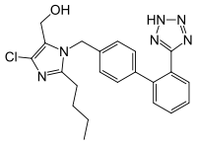
Losartan and its active metabolite (EXP-3174) blocks angiotensin II receptors (subtype AT1) in various tissues, including the adrenal cortex, brain, kidneys, liver, vascular smooth muscle, heart and prevents the development of the effects of angiotensin II. Reduces arterial vasoconstriction, reduces total peripheral vascular resistance, reduces afterload (blood pressure in the aorta by reducing peripheral vascular resistance to blood flow), pressure in the pulmonary circulation, prevents the development of myocardial hypertrophy, lowers wedge pressure in the pulmonary vessels, inhibits the release of aldosterone, reduces concentration of norepinephrine in the blood. Prevents sodium and water retention in the body without causing a natriuretic effect (the excretion of sodium ions in the urine). It has a diuretic effect, reducing the concentration of uric acid in the blood, increasing its excretion in the urine. Increases exercise tolerance in patients with heart failure. Increases the activity of renin in the blood plasma. Losartan does not bind or block other hormone receptors and ion channels important for cardiovascular regulation. Does not inhibit angiotensin-converting enzyme (ACE), does not affect the kinin system, does not inhibit kinase II, an enzyme that destroys bradykinin.
Synthesis of losartan:
Ibresartan
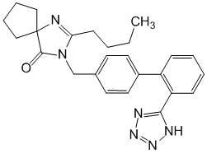
Highly specific and irreversible blocks angiotensin II receptors (subtype AT1). Eliminates the vasoconstrictive effect of angiotensin II, lowers the concentration of aldosterone in plasma, reduces round robin, afterload on the heart, systemic blood pressure and pressure in the pulmonary circulation. Does not affect kinase I6I (ACE), which destroys bradykinin and is involved in the formation of angiotensin II. Indications: Arterial hypertension, nephropathy in arterial hypertension and type 2 diabetes mellitus (as part of combined antihypertensive therapy).
Candesartan
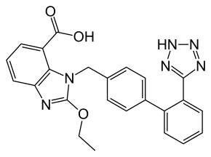
Candesartan is characterized by the formation of a stable long-term bond with AT1 receptors and the slow dissociation of this bond. Due to this, candesartan preparations have a pronounced antihypertensive effect that lasts more than 24-36 hours. This effect does not depend on the sex, age and body weight of the patient. Candesartan does not contribute to the accumulation of bradykinin, does not affect or inhibit ACE.
The drug can be prescribed for the following diseases: arterial hypertension, left ventricular hypertrophy, diabetic nephropathy, etc.
Valsartan
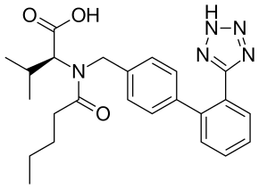
The active hormone of the renin-angiotensin-aldosterone system is angiotensin II, which is formed from angiotensin I due to the action of angiotensin-converting enzyme. In addition, this process can take place under the action of chymases, cathepsin, and other enzymes, both voluntarily and as a result of ACE blockade. Angiotensin II binds to specific receptors located on the cell membranes of many tissues. Four to seven angiotensin II receptor subtypes have been described. The interaction of angiotensin II with receptors is manifested by a wide range of physiological effects, which include both direct and indirect effects on the regulation of blood pressure. As a vasoconstrictor, angiotensin II has a direct pressor effect when interacting with AT1 subtype receptors. In addition, when interacting with type 1 receptors, fibroblasts are stimulated, their subsequent differentiation into fibrocytes and, as a result, the growth of connective tissue. Also, angiotensin II reduces the excretion of sodium from the body and stimulates the secretion of aldosterone.
Telmisartan
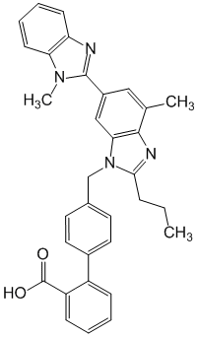
Angiotensin II is formed from angiotensin I in a reaction catalyzed by ACE (kininase II). Angiotensin II is the main pressor agent of the RAAS, its effects include vasoconstriction, stimulation of aldosterone synthesis and release, cardiac stimulation, and sodium reabsorption in the kidneys. Telmisartan blocks the vasoconstrictive and aldosterone-secreting effects of angiotensin II by selectively blocking the binding of angiotensin II to AT1 receptors in many tissues, such as vascular smooth muscle and adrenal glands. Its action is thus independent of angiotensin II synthesis pathways.

Calcium channel blockers
Calcium antagonists (drugs blocking L-type calcium channels; slow calcium channel blockers (SCB)) are a heterogeneous group of drugs that have the same mechanism of action, but differ in a number of properties, including pharmacokinetics, tissue selectivity, and effects on heart rate. abbreviations.
Classification based on chemical structure:
• phenylalkylamines (verapamil, gallopamil)
• benzothiazepines (diltiazem, klentiazem)
• 1,4-dihydropyridines (nifedipine, nitrendipine, isradipine, nicardipine, nimodipine, amlodipine, levamlodipine, lacidipine, felodipine, lercanidipine)
• diphenylpiperazines (cinnarizine, flunarizine)
• diarylaminopropylamines (bepridil)

From a practical point of view (depending on the effect on the tone of the sympathetic nervous system and heart rate), calcium antagonists are divided into two subgroups:
• reflexively increasing heart rate (dihydropyridine derivatives) and
• reflexively reducing the heart rate (verapamil and diltiazem) - the action is largely similar to beta-blockers.
According to the classification given by I.B. Mikhailov (2001), the BPC is divided into three generations:
• First generation:
a) verapamil (Isoptin, Finoptin) - derivatives of phenylalkylamine;
b) nifedipine (Fenigidin, Adalat, Korinfar, Kordafen, Kordipin) - derivatives of dihydropyridine;
c) diltiazem (Diazem, Diltiazem) - derivatives of benzothiazepine.
• Second generation:
a) verapamil group: gallopamil, anipamil, falipamil;
b) nifedipine group: isradipine (Lomir), amlodipine (Norvasc), levamlodipine (Azomex), felodipine (Plendil), nitrendipine (Octidipine), nimodipine (Nimotop), nicardipine, lacidipine (Lacipil), riodipine (Foridon);
c) diltiazem group: klentiazem.
Compared to first-generation CCBs, second-generation CCBs have a longer duration of action, higher tissue specificity, and fewer side effects.
• Third generation (naftopidil, emopamil, lercanidipine)
The third generation CCB has a number of additional properties, such as alpha-adrenolytic (naftopidil) and sympatholytic activity (emopamil).
The main mechanism of action of calcium antagonists is that they inhibit the penetration of calcium ions from the intercellular space into the muscle cells of the heart and blood vessels through slow L-type calcium channels. By reducing the concentration of Ca2+ ions in cardiomyocytes and vascular smooth muscle cells, they dilate the coronary arteries and peripheral arteries and arterioles, and have a pronounced vasodilating effect.
Nifedipine
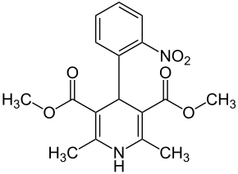
Calcium channel blocker. It inhibits the flow of calcium ions through the membrane of cardiomyocytes and vascular smooth muscles, which leads to a decrease in the accumulation of calcium inside the cells. This causes the expansion of the coronary arteries, peripheral blood vessels, which leads to a decrease in total peripheral vascular resistance (OPVR) and, consequently, a decrease in the load on the heart, an increase in myocardial oxygen supply. By reducing the work of the heart, the drug reduces myocardial oxygen consumption, and also indirectly reduces myocardial oxygen demand by reducing peripheral vascular resistance and afterload.
Inhibition of the entry and accumulation of calcium ions in cardiomyocytes prevents the depletion of myocardial energy reserves and provides a protective effect on the heart muscle.
Under the influence of the drug, blood pressure (BP) decreases, chest pain associated with myocardial hypoxia disappears or decreases. Due to the vasodilating effect on the coronary arteries, post-stenotic circulation improves in atherosclerotic obstruction.
Synthesis of nifedipine:

Indications for use:
• arterial hypertension;
• stable angina pectoris (angina pectoris);
• angiospastic angina;
• prevention of migraine attacks;
• renal, gallstone, intestinal colic and other conditions that require a strong antispasmodic effect.

Isradipin
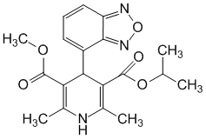
Blocks calcium channels, inhibits the entry of calcium ions into the smooth muscle cells of the vascular wall and myocardiocytes, reduces their ability to contract. Shows selectivity for vascular smooth muscle compared to the myocardium. A decrease in the concentration of calcium ions in the cells of the smooth muscles of the vascular system leads to the expansion of the coronary arteries and peripheral arteries and arterioles. The hypotensive effect, mainly due to vasodilation and a decrease in peripheral vascular resistance, is accompanied by reflex tachycardia, which masks the negative inotropic effect. Does not depress the sinoatrial or atrioventricular node. It has diuretic properties (the mechanism of increased diuresis is unclear).
Amlodipine
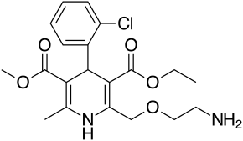
Amlodipine is a 2nd generation calcium channel blocker with antianginal and hypotensive effects. The drug is a mixture of stereoisomers. A derivative of dihydropyridine - BMKK 3 generations, has an antianginal and hypotensive effect. By binding to dihydropyridine receptors, it blocks calcium channels, reduces the transmembrane transition of Ca2 + into the cell (to a greater extent into vascular smooth muscle cells than into cardiomyocytes). The antianginal effect is due to the expansion of the coronary and peripheral arteries and arterioles: in angina pectoris, it reduces the severity of myocardial ischemia; expanding peripheral arterioles, reduces peripheral vascular resistance, reduces afterload on the heart, reduces myocardial oxygen demand.
Pharmacologically active is Levamlodipine (S-amlodipine).
Levamlodipine (S-amlodipine) is the active levorotatory isomer of amlodipine, a blocker of slow L-type calcium channels. It blocks the flow of calcium ions through the membranes into the smooth muscle cells of the myocardium and blood vessels. R-amlodipine is an active dextrorotatory isomer, which is responsible for the antisclerotic, antioxidant and antiproliferative properties of the drug. The mechanism of hypotensive action is due to a decrease in the tone of the vascular wall. The antianginal effect is realized by reducing the total peripheral resistance of the peripheral vascular resistance, afterload, myocardial oxygen demand, reducing the tone of the coronary vessels and preventing vasospastic reactions.

Felodipine
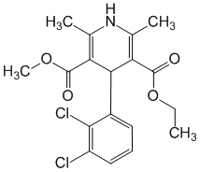
Interacts with dihydropyridine receptors and inhibits the passage of calcium ions into cells. It acts from the inside of the membrane and more effectively binds to the calcium channels of the depolarized membrane, changing their function. Lowers the concentration of calcium ions mainly in vascular smooth muscle cells, incl. coronary, and to a lesser extent in cardiomyocytes. Causes expansion of peripheral vessels (arterioles, arteries), reduces peripheral vascular resistance, lowers blood pressure (possible slight reflex tachycardia). Does not affect the smooth muscles of the veins (does not cause orthostatic hypotension). Indications: Arterial hypertension, angina (stable angina, including Prinzmetal's angina, with an unstable form in case of intolerance or ineffectiveness of beta-blockers or nitrates), Raynaud's syndrome.
Nicardipine
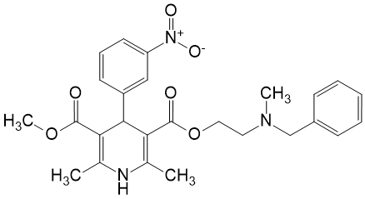
In the cytoplasmic membrane, it selectively blocks calcium channels (and disrupts their formation) for incoming slow currents of calcium ions and reduces its intracellular content. It relaxes the smooth muscle cells of the vascular wall, predominantly of arterial vessels, which leads to their expansion, a decrease in OPSS, and a decrease in systemic blood pressure. In response to a decrease in peripheral resistance, it can cause reflex tachycardia. Improves blood supply to the brain and coronary blood flow, increases perfusion in the ischemic zone of the myocardium. It does not significantly affect the conductivity and contractility of the myocardium. It has an antiaggregatory effect by reducing the calcium content in platelets.
Nimodipine
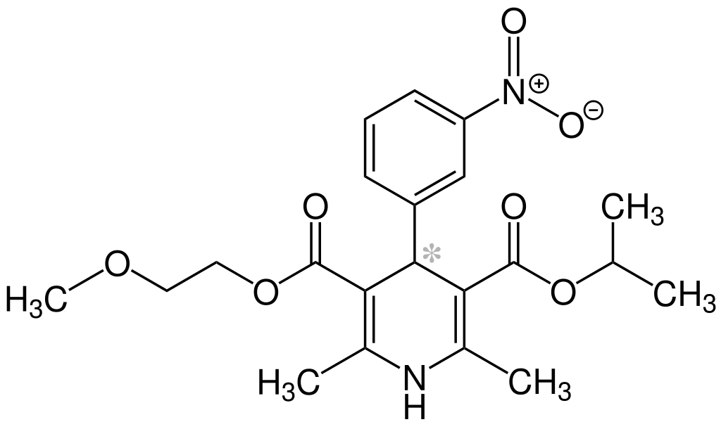
Selective calcium channel blocker class II, dihydropyridine derivative. Selectively interacts with type L calcium channels and blocks the transmembrane entry of calcium ions. It has a vasodilating effect mainly on the vessels of the brain. Prevents or eliminates vasospasm caused by various vasoconstrictor biologically active substances. Causes a more pronounced increase in perfusion in areas of the brain with insufficient blood supply (compared to areas with normal blood supply). Improves cerebral circulation in subarachnoid hemorrhage. Stabilizes the functional state of brain neurons. Improves memory and ability to concentrate. It does not have a significant effect on systemic blood pressure, has practically no effect on conduction in the AV and sinoatrial nodes and on myocardial contractility. Reflexively increases heart rate in response to vasodilation.
Nisoldipine
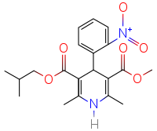
Calcium channel blocker, is a derivative of dihydropyridine. It acts mainly on arterial vessels. Violating the penetration of calcium ions into cells, causes relaxation of the smooth muscles of the vascular wall. Stops (relieves) spasm (sharp narrowing of the lumen) and expands the peripheral and coronary (cardiac) arteries, increases coronary blood flow, reduces total peripheral resistance (vascular resistance to blood flow) and afterload on the heart (reduces blood pressure in the aorta by reducing peripheral vascular resistance ). Reduces the demand of the myocardium (heart muscle) for oxygen. Slightly reduces myocardial contractility. It has some natriuretic effect (excretion of sodium ions in the urine).
Nitrendipine
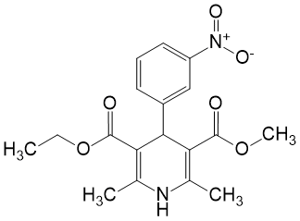
Specifically binds to membrane receptors that regulate the function of voltage-gated L-type calcium channels, reduces the flow of calcium ions into the cell during membrane depolarization. It mainly affects the smooth muscle cells of the vessels (less coronary than others). It has a highly selective long-term vasodilating effect. It causes systemic vasodilation, a decrease in peripheral vascular resistance, and, as a result, hypotension. Lowers blood pressure in proportion to the dose, does not cause orthostatic hypotension and the development of tolerance, does not violate the circadian rhythm of blood pressure changes. Expands the vessels of the kidneys, increases the blood levels of atrial natriuretic peptide, increases the excretion of sodium and water, does not activate the sympathoadrenal (heart rate usually does not change) and renin-aldosterone (the content of angiotensin and renin in plasma does not increase significantly) systems. However, at the beginning of therapy, short-term reflex tachycardia may occur. Does not affect the sinus and AV nodes.
Barnidipine
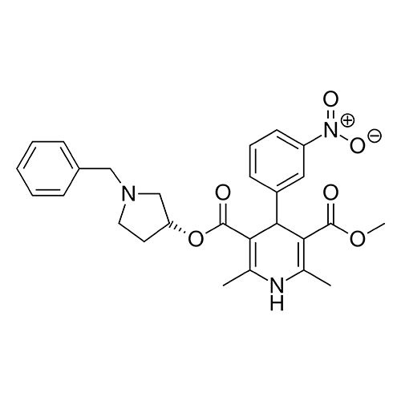
Barnidipine is a calcium channel blocker (dihydropyridine type), has an antihypertensive effect. Reduces peripheral resistance and blood pressure.
Lercanidipine
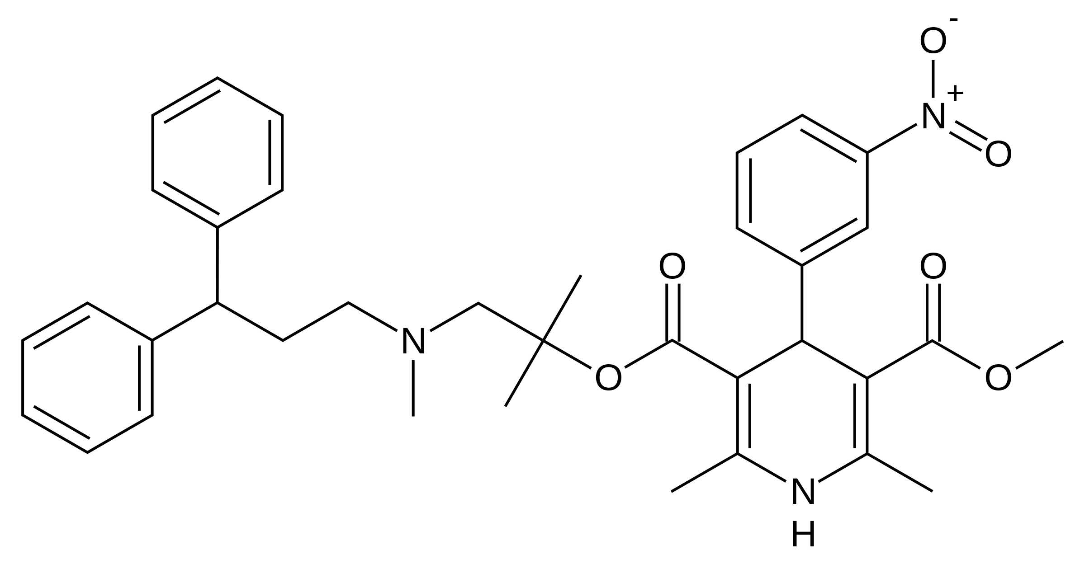
General method for the synthesis of 1,4-dihydropyridine derivatives:
Aromatic aldehyde, acetoacetic acid esters and ammonia react under pressure or for a long time.

If the ester groups are different, different acetoacetic acid esters are used.
The synthesis process can also be carried out using suitable aminocrotonoate derivatives instead of acetoacetate derivatives.
Structure-activity relationship:
Structural changes have been made in various studies on 1,4-dihydropyridine derivatives to increase bioavailability, alter duration of action, or minimize effects. The relationships between structure and activity identified for this group of compounds can be listed as follows.
-The 1,4-dihydropyridine ring has been found to be essential for optimal activity. The need to protect the ring to achieve the effect is emphasized. Oxidation or reduction of the ring reduces activity.
- The most important changes in the basic structure of nifedipine concerned the ester function at positions 3 and 5. The ester substituents at positions 3 and 5 greatly affect the activity and selectivity of 1,4-dihydropyridine. It has been shown that compounds with different ester substituents in positions 3 and 5 have a stronger vasodilating effect than compounds with the same substituents.
-In the case of a center of asymmetry in the 4th position of the dihydropyridine ring, the effect can be an agonist-antagonist in enantiomers, an example of which is BayK8644.

Replacement of the ester function by various carbonyl functional groups such as acyl, amide, sulfonyl, nitrile has led to the emergence of drugs that cause calcium modulation.
-The presence of small alkyl groups in the 2nd and 6th positions leads to optimal activity. The 2,6-dimethyl substitution is most suitable for activity. However, activity is also observed in compounds in which the alkyl group is replaced by an amino, cyano, or formyl group.
-Compounds with a substituted aryl and/or heteroaryl structure are ideal.
Its steric factors have been reported to be very effective with respect to activity. The lowest level of ring bending was registered in compounds containing non-hydrogen groups in the ortho-position of the phenyl ring with the dihydropyridine ring in the boat conformation. Replacing the phenyl ring from no-and/or-positions is advantageous in terms of activity.
To improve the bioavailability of the drug in the structure of 1,4-dihydropyridine, the nitrogen atom in position 1 was focused and it was emphasized that this position should not contain substituents.
The influence of compounds containing a substituent in the 4th position of the 1,4-dihydropyridine structure and substituents forming ester groups in the 3rd and 5th positions affects vascular selectivity.
Verapamil analogues
Later, the most important representative of this group, verapamil halopamil, was developed. Verapamil is a drug that was originally considered a beta receptor blocker. In chemical structure, it is close to papaverine. after verapamil was the active compound, a calcium antagonist.
The two compounds of this group, verapamil and halopamil, are prepared in a racemic manner. For the synthesis of compounds 3,4-dimethoxyphenylacetonitrile/2,3,4-trimethoxyphenyl-acetonitrile-isopropyl chloride is alkylated in the presence of sodium amide 2-(3,4-dimethoxyphenyl)-2-isopropylacetonitrile-2-trimethylacetonitrile-2-isopropylacetonitrile-2-isopropylacetonitrile-dimethylphenyltonitrile N-(3-chloropropyl)-N-methyl-N-[2-(3,4-dimethoxyphenyl)ethyl]amine was obtained by condensation of bromine-3-chloropropane and N-[2-(3,4-dimethoxyphenyl)ethyl]- N-methylamine in the presence of sodium amide The synthesis of compounds was completed by the reaction of 1,2-(3,4-dimethoxyphenyl)-2-isopropylacetonitrile /2-(2,3,4-trimethoxyphenyl)-2-isopropylacetonitrile.
Verapamil
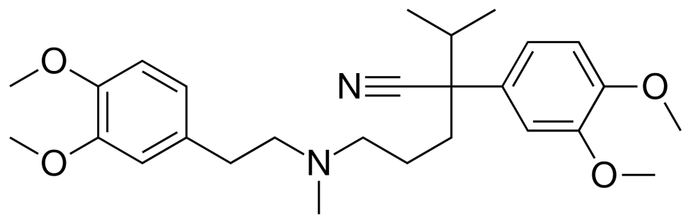
Verapamil is a voltage-gated L-type calcium channel blocker. Affects more on the myocardium than on the vessels. In therapeutic doses, it slows down and weakens heart contractions, inhibits sinoatrial and atrioventricular conduction, reduces the automatism of the heart muscle, due to which it has an antiarrhythmic effect. Refers to antiarrhythmic drugs of group IV. Verapamil causes expansion of the coronary vessels of the heart and increases coronary blood flow; lowers the heart's need for oxygen. In ischemic processes in the myocardium, the drug helps to reduce the disproportion between the need and supply of oxygen to the heart, both by increasing blood supply and by better utilization and more economical use of the delivered oxygen.
A decrease in heart rate and difficulty in atrioventricular conduction is associated with a slowdown in the incoming calcium current into the cardiomyocytes of the nodes (Fig. 1). On the electrocardiogram after the use of verapamil, an increase in the P-P and P-Q (R) intervals is noted. The weakening of the strength of heart contractions is explained by a decrease in the supply of calcium ions to the cardiomyocytes of the working myocardium.
Despite the fact that verapamil reduces myocardial contractility, due to its vasodilating effect and a decrease in vascular resistance, cardiac output does not change significantly. By blocking the entry of calcium ions into platelets, verapamil inhibits their aggregation. In addition, it has some natriuretic and diuretic effect by reducing tubular reabsorption.
In the mechanism of antianginal action of verapamil, along with antagonism towards calcium ions, an increase in the content of potassium ions in myocardial cells also plays a role.
Gallopamil
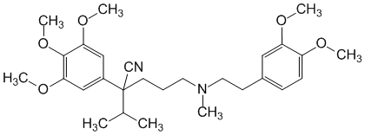
Phenylalkylamine, a methoxylated derivative of verapamil. It is a competitive antagonist of calcium ions. Reversibly blocks calcium channels. It has antianginal and antiarrhythmic effects. Reduces myocardial oxygen demand by reducing myocardial contractility and slowing heart rate. It causes expansion of the coronary arteries and an increase in coronary blood flow. Reduces the tone of the smooth muscles of the peripheral arteries and the overall peripheral vascular resistance. Indications: Prevention of angina attacks (including Prinzmetal's angina pectoris). Secondary prevention of myocardial infarction. Arterial hypertension. Treatment and prevention of supraventricular arrhythmias (paroxysmal supraventricular tachycardia, atrial fibrillation, atrial flutter, extrasystole). Secondary prevention of myocardial infarction.

Diphenylalkylamines
Synthesis of diphenylalkylamine derivatives:

Fendilin
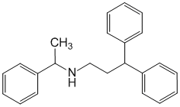
Non-selectively blocks calcium channels (including L-type), lowers the concentration of intracellular calcium in smooth muscle cells (including peripheral and coronary vessels) and cardiomyocytes. Inhibits the calmodulin protein involved in calcium-dependent processes. Increases coronary blood flow and oxygen supply to the heart, increases myocardial resistance to hypoxia. Expands peripheral vessels and lowers blood pressure. Suppresses the automatism of the sinus node and conduction along the AV connection (lengthening of the QRS complex and PQ and QT intervals on the ECG). It has a negative inotropic effect and causes reflex tachycardia. Reduces pulmonary hypertension, dilates the bronchi. It is effective for mild coronary insufficiency, obliterating atherosclerosis of the vessels of the lower extremities in patients suffering from coronary artery disease, transient disorders of cerebral circulation and chronic cerebrovascular insufficiency.
Prenylamine
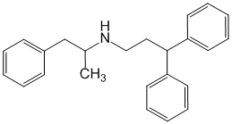
Prenylamine has a moderate antianginal (anti-ischemic effect) due to coronary dilating (dilating the blood vessels of the heart) activity. It acts as a calcium channel blocker, inhibiting (suppressing) the transmembrane flow of calcium ions, but is inferior in this respect to nifedipine and verapamil. It does not significantly affect the contractility of the myocardium (heart muscle). It has some antiadrenergic effect, reduces peripheral vascular resistance (vascular resistance to blood flow) and may cause a moderate decrease in blood pressure. Improves metabolic processes (metabolism) in the myocardium. It has quinidine-like (antiarrhythmic) and weak sedative (calming) effects.
Lidoflazil
Synthesis:

Lidoflazin causes an expansion of the coronary vessels (vessels of the heart) and an increase in coronary (through the vessels of the heart) blood flow; with prolonged use, collateral circulation improves (through small vessels, bypassing the main artery). It has no significant effect on blood pressure, frequency and strength of heart contractions. The mechanism of action of the drug is associated with an antispasmodic (relieving spasms) effect on vascular smooth muscles and potentiation (intensification) of the coronary dilating (expanding heart vessels) action of adenosine formed in the myocardium (heart muscle).
Perhexilin
Perhexilin is thought to act by inhibiting mitochondrial carnitine palmitoyltransferase-1. This shifts myocardial metabolism from fatty acid to glucose utilization, which results in increased ATP production for the same O 2 consumption and hence increases myocardial efficiency. Its clinical use is limited by its narrow therapeutic index and high inter- and intra-individual pharmacokinetic variability. It has been banned in many countries due to its adverse effects on bad metabolizers (PM).
Other drugs
Diltiazem

Synthesis:

Metabolism of diltiazem:

It is similar in action to verapamil, but has a slightly stronger effect on vascular smooth muscles and the conduction system of the heart and less inhibits the inotropic function of the myocardium. Compared with nifedipine, peripheral vasodilator action and reflex tachycardia are less pronounced [1].
Diltiazem blocks voltage-gated L-type calcium channels and inhibits the entry of calcium ions into the depolarization phase of cardiomyocytes and vascular smooth muscle cells (reduces intracellular Ca2+ content). As a result of inhibition of the slow depolarizing flow of calcium into the cells of excitable tissues, it inhibits the formation of an action potential and uncouples the excitation-contraction process. Reduces myocardial contractility, slows down AV conduction, reduces heart rate (does not change or slightly reduces the maximum heart rate during exercise), reduces myocardial oxygen demand by several mechanisms (reducing energy consumption by myocardial cells; reducing the activity of the system of formation and conduction of excitation with parallel inhibition of tachycardiac reactions; decrease in the tone of peripheral arteries and arterioles with a parallel decrease in OPSS, blood pressure, i.e. after exercise), dilates coronary arteries, increases coronary blood flow, prevents or eliminates coronary spasm, reduces the tone of smooth muscles of peripheral arteries and OPSS, shows (not always) a slight negative inotropic effect (at concentrations at which there is no negative inotropic effect, diltiazem causes relaxation of the smooth muscles of the coronary vessels and dilatation of both large and small arteries), rarely causes postural hypotension and reflex tachycardia, st improves cerebral and renal blood flow.
It has a dose-dependent antihypertensive effect in mild to moderate hypertension. The degree of reduction in blood pressure correlates with the level of hypertension (in people with normal blood pressure, there is only a minimal decrease in blood pressure). The hypotensive effect is manifested both in the horizontal and in the vertical position.
Combined drugs:
Combinations of two antihypertensive drugs are divided into rational (proven), possible and irrational. Rational combinations: ACE inhibitor + diuretic, ARB + ​​diuretic, ACC + diuretic, ARB + ​​ACC, ACE inhibitor + ACC, β-AB + diuretic. There are fixed combinations (in one tablet) in the form of ready-made dosage forms that have significant ease of use and increase patient adherence to treatment:
• ACE inhibitor + diuretic (Noliprel A, Ko-renitek, Enap N, Fozicard N, Berlipril plus, Rami-Hexal compositum, Liprazide, Enalozide, Co-Diroton)
• ACE inhibitor + Calcium antagonist (Equator, Gipril A, Prestans, Rami-Azomeks)
• ARB + ​​diuretic (Gizaar, Losarel Plus, Co-Diovan, Lozap+, Valz (Vazar) N, Diocor, Micardis plus)
• ARB + ​​Calcium Antagonist (Amzaar, Exforge, Lo-Azomex)
• Calcium antagonist (dihydropyridine) + β-AB (Beta-Azomex)
• Calcium antagonist (non-dihydropyridine) + ACE inhibitor (Tarka)
• Calcium antagonist (dihydropyridine) + diuretic (Azomex N)
• β-AB + diuretic (Lodoz)
One of the most used is the combination of ACE inhibitors and diuretics. Indications for the use of this combination: diabetic and non-diabetic nephropathy, microalbuminuria, left ventricular hypertrophy, diabetes mellitus, metabolic syndrome, old age, isolated systolic hypertension.

Hypertensive agents.
Hypotension, or, as this phenomenon is also called, arterial hypotension, is a condition of the human body in which blood pressure is reduced compared to normal values.
To normalize vascular tone, heart rate, neutralize the impact of negative environmental factors, the following groups of drugs are prescribed: adaptogens, psychomotor stimulants, analeptics, adrenomimetics (for emergency care with a sharp drop in pressure), anticholinergics (for vagotonia), nootropics, complexes of vitamins with minerals and others
Drugs used in the treatment of hypotension include: adrenaline, dopamine, ephedrine, midodrine. Information about these drugs is presented in lecture No. 3. Drug treatment of hypotension may be accompanied by the intake of general tonic adaptogen preparations, stimulants (in particular, coffee and tea, ginseng, magnolia vine, eleutherococcus), baths with plant decoctions, the use of herbal teas, etc.

